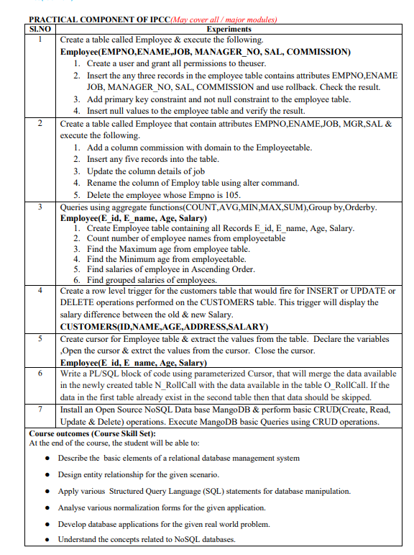
LAB MANUAL

AY: 2023 – 24 (EVEN SEMESTER)
SEMESTER: 4
DEPT(s): CSE-ALLIED BRANCHES
SUBJECT NAME: DATABASE MANAGEMENT SYSTEM
SUBJECT CODE: BCS403

Experiment 1:
Create a table called Employee & execute the following.
create database ai_ml_b3;
use ai_ml_b3;
Employee(EMPNO,ENAME,JOB, MANAGER_NO, SAL, COMMISSION)
create table Employee(empno int,ename varchar(25),job varchar(20),manager_no int,sal decimal(10,2),commission decimal(8,2));
desc Employee;
1. Create a user and grant all permissions to the user.
create user 'aiml_b3'@'localhost' identified by 'aiml';
grant all privileges on Employee to 'aiml_b3'@'localhost';
2. Insert the any three records in the employee table contains attributes EMPNO,ENAME JOB, MANAGER_NO, SAL, COMMISSION and use rollback. Check the result.
SET autocommit=0;
INSERT INTO Employee (EMPNO, ENAME, JOB,
MANAGER_NO, SAL,COMMISSION) VALUES
(101, 'John Doe', 'Manager', NULL, 50000, 2000),
(102, 'Jane Smith', 'Developer', 101, 45000, 1500),
(103, 'Bob Johnson', 'Analyst', 101, 40000, 1000);
select * from Employee;
rollback;
select * from Employee;
3. Add primary key constraint and not null constraint to the employee table.
alter table Employee add primary key(empno);
alter table Employee modify ename varchar(50) NOT NULL;

desc Employee;
4. Insert null values to the employee table and verify the result.
INSERT INTO EMPLOYEE (EMPNO,ENAME,JOB,MANAGER_NO,SAL,COMMISSION) VALUES (105,NULL,’MANAGER’,NULL,50000,2000);

Experiment 2:
Create a table called Emp that contain attributes
EMPNO,ENAME,JOB, MGR,SAL & execute the following.
create table Emp(empno int primary key,ename varchar(25),
job varchar(20),mgr int,sal decimal(10,2));
1. Add a column commission with domain to the Employee table.
alter table Emp add commission decimal(8,2);
2. Insert any five records into the table.
INSERT INTO Emp (empno, ename, job,
mgr, sal,commission) VALUES
(101, 'John Doe', 'Manager', NULL, 50000, 2000),
(102, 'Jane Smith', 'Developer', 101, 45000, 1500),
(103, 'Bob Johnson', 'Analyst', 101, 40000, 1000),
(104, 'John Smith', 'Cashier', 101, 40000, 1800),
(105, 'Bob Doe', 'Developer', 101, 60000, 2000);
3. Update the column details of job
alter table Emp modify job varchar(100);
4. Rename the column of Employ table using alter command.
alter table Emp rename to Emp1; (using alter) or
rename table Emp to Emp1; (without using alter)
5. Delete the employee whose empno is 105.
delete from Emp where empno=105;

Experiment 3:
Queries using aggregate functions(COUNT,AVG,MIN,MAX,SUM),Group by,
Orderby.
Employee(E_id, E_name, Age, Salary)
1. Create Employee table containing all Records E_id, E_name, Age, Salary.

Create table Employee(E_id int primary key,E_name varchar(50),
Age int,Salary Decimal(10,2));

Desc Employee

Field | Type | Null | Key | Default | Extra |
+-------+---------------+------+-----+---------+-------+
| e_id | int | NO | PRI | NULL | |
| e_name | varchar(50) | YES | | NULL | |
| age | int | YES | | NULL | |
| sal | decimal(10,2) | YES | | NULL |

Insert into Employee values(1,’John Doe’,30,50000.0),
(2,’Jane Smith’,25,45000.0),
(3,’Michael Johnson’,35,60000.0),
(4,Emily Brown’,28,48000.0),
(5,’David Lee’,32,55000.0));

2. Count number of employee names from employee table
select count(e_name) as No_of_Employees from Employee;

3. Find the Maximum age from employee table.
select max(age) as MaxAge from Employee;

4. Find the Minimum age from employee table.
select min(age) as MinAge from Employee;

5. Find salaries of employee in Ascending Order.
select sal as Employee_Salary from Employee order by sal asc;

6. Find grouped salaries of employees.
select sal,count(*) as Employee_Count from Employee group by sal;

Experiment 4:
Create a row level trigger for the customers table that would fire for INSERT or UPDATE or DELETE operations performed on the CUSTOMERS table.

This trigger will display the salary difference between the old & new Salary.

Trigger: A trigger is a stored procedure in a database that automatically invokes whenever a special event in the database occurs. For example, a trigger can be invoked when a row is inserted into a specified table or when specific table columns are updated. In simple words, a trigger is a collection of SQL statements with particular names that are stored in system memory. It belongs to a specific class of stored procedures that are automatically invoked in response to database server events. Every trigger has a table attached to it.
Because a trigger cannot be called directly, unlike a stored procedure, it is referred to as a special procedure. A trigger is automatically called whenever a data modification event against a table takes place, which is the main distinction between a trigger and a procedure. On the other hand, a stored procedure must be called directly.
The following are the key differences between triggers and stored procedures:
- Triggers cannot be manually invoked or executed.
- There is no chance that triggers will receive parameters.
- A transaction cannot be committed or rolled back inside a trigger.

Syntax:
create trigger [trigger_name]
[before | after]
{insert | update | delete}
on [table_name]
[for each row]
[trigger_body]

- Create trigger [trigger_name]: Creates or replaces an existing trigger with the trigger_name.
- [before | after]: This specifies when the trigger will be executed.
- {insert | update | delete}: This specifies the DML operation.
- On [table_name]: This specifies the name of the table associated with the trigger.
- [for each row]: This specifies a row-level trigger, i.e., the trigger will be executed for each affected row.
- [trigger_body]: This provides the operation to be performed as the trigger is fired

CUSTOMERS(ID,NAME,AGE,ADDRESS,SALARY)

create table customers(id int primary key,name varchar(25),age int,address varchar(50),salary decimal(10,2));

insert into customers(id,name,age,address,salary) values
(1,'John Doe',30,'123, Main St, Anytown, USA',50000.0),
(2,'Jane Smith',25,'456, Elm St, Othertown, USA',60000.0),
(3,'Bob John Son',40,'789, Oak St, Anothertown, USA',75000.0);

DELIMITER //

Create Trigger for INSERT Operation

CREATE TRIGGER after_insert_salary_difference
AFTER INSERT ON CUSTOMERS
FOR EACH ROW
BEGIN
SET @my_sal_diff = CONCAT('salary inserted is ', NEW.SALARY);
END;//

Create Trigger for UPDATE Operation

CREATE TRIGGER after_update_salary_difference
AFTER UPDATE ON CUSTOMERS
FOR EACH ROW
BEGIN
DECLARE old_salary DECIMAL(10, 2);
DECLARE new_salary DECIMAL(10, 2);
SET old_salary = OLD.SALARY;
SET new_salary = NEW.SALARY;
SET @my_sal_diff = CONCAT('salary difference after update is ', new_salary - old_salary);
END;//

Create Trigger for DELETE Operation
CREATE TRIGGER after_delete_salary_difference
AFTER DELETE ON CUSTOMERS
FOR EACH ROW
BEGIN
SET @my_sal_diff = CONCAT('salary deleted is ', OLD.SALARY);
END;//

Delimiter ;

Testing the Trigger:
Insert Operation:

INSERT INTO CUSTOMERS (id, NAME, AGE, ADDRESS, SALARY)VALUES (4,'Shankara', 35, '123 Main St', 50000.00);

SELECT @my_sal_diff AS SAL_DIFF;
Update Operation:

UPDATE CUSTOMERS SET SALARY = 55000.00 WHERE ID = 1;

SELECT @my_sal_diff AS SAL_DIFF;

Delete Operation:

DELETE FROM CUSTOMERS WHERE ID = 1;

SELECT @my_sal_diff AS SAL_DIFF;

Experiment 5:
Create cursor for Employee table & extract the values from the table. Declare the variables ,Open the cursor & extrct the values from the cursor. Close the cursor.
Employee(E_id, E_name, Age, Salary)

1. Creating the Employee Table and insert few records
CREATE DATABASE COMPANY05;

USE COMPANY05;

CREATE TABLE Employee (
E_id INT,
E_name VARCHAR(255),
Age INT,
Salary DECIMAL(10, 2)
);

INSERT INTO Employee (E_id, E_name, Age, Salary)
VALUES
(1, 'Samarth', 30, 50000.00),
(2, 'Ramesh Kumar', 25, 45000.00),
(3, 'Seema Banu', 35, 62000.00),
(4, 'Dennis Anil', 28, 52000.00),
(5, 'Rehman Khan', 32, 58000.00);

2. Create a Stored Procedure with Cursor
To create a cursor for the Employee table, extract values using the cursor, and then close the cursor in MySQL, you’ll need to use stored procedures that support cursor operations.

DELIMITER //

CREATE PROCEDURE fetch_employee_data()
BEGIN
-- Declare variables to store cursor values
DECLARE emp_id INT;
DECLARE emp_name VARCHAR(255);
DECLARE emp_age INT;
DECLARE emp_salary DECIMAL(10, 2);

-- Declare a cursor for the Employee table
DECLARE emp_cursor CURSOR FOR
SELECT E_id, E_name, Age, Salary
FROM Employee;

-- Declare a continue handler for the cursor
DECLARE CONTINUE HANDLER FOR NOT FOUND
SET @finished = 1;

-- Open the cursor
OPEN emp_cursor;

-- Initialize a variable to control cursor loop
SET @finished = 0;

-- Loop through the cursor results
cursor_loop: LOOP
-- Fetch the next row from the cursor into variables
FETCH emp_cursor INTO emp_id, emp_name, emp_age, emp_salary;

-- Check if no more rows to fetch
IF @finished = 1 THEN
LEAVE cursor_loop;
END IF;

-- Output or process each row (for demonstration, print the values)
SELECT CONCAT('Employee ID: ', emp_id, ', Name: ', emp_name, ', Age: ', emp_age, ', Salary: ', emp_salary) AS Employee_Info;
END LOOP;

-- Close the cursor
CLOSE emp_cursor;
END//

DELIMITER ;

In this stored procedure (fetch_employee_data):
- We declare variables (emp_id, emp_name, emp_age, emp_salary) to store values retrieved from the cursor.
- A cursor (emp_cursor) is declared to select E_id, E_name, Age, and Salary from the Employee table.
- We declare a continue handler (CONTINUE HANDLER) for NOT FOUND condition to handle the end of cursor data.
- The cursor is opened (OPEN emp_cursor), and a loop (cursor_loop) is used to fetch each row from the cursor.
- We fetch values into the variables and process them within the loop (for demonstration, we print the values using a SELECT statement).
- The loop continues until all rows are fetched (@finished = 1).
- Finally, the cursor is closed (CLOSE emp_cursor).

3. Execute the Stored Procedure
Once the stored procedure fetch_employee_data is created, you can execute it to fetch and process data from the Employee table:
CALL fetch_employee_data();
Output:
+----------------------------------------------------------+
| Employee_Info |
+----------------------------------------------------------+
| Employee ID: 1, Name: Samarth, Age: 30, Salary: 50000.00 |
+----------------------------------------------------------+
1 row in set (0.07 sec)

+---------------------------------------------------------------+
| Employee_Info |
+---------------------------------------------------------------+
| Employee ID: 2, Name: Ramesh Kumar, Age: 25, Salary: 45000.00 |
+---------------------------------------------------------------+
1 row in set (0.07 sec)

+-------------------------------------------------------------+
| Employee_Info |
+-------------------------------------------------------------+
| Employee ID: 3, Name: Seema Banu, Age: 35, Salary: 62000.00 |
+-------------------------------------------------------------+
1 row in set (0.07 sec)

+--------------------------------------------------------------+
| Employee_Info |
+--------------------------------------------------------------+
| Employee ID: 4, Name: Dennis Anil, Age: 28, Salary: 52000.00 |
+--------------------------------------------------------------+
1 row in set (0.07 sec)

+--------------------------------------------------------------+
| Employee_Info |
+--------------------------------------------------------------+
| Employee ID: 5, Name: Rehman Khan, Age: 32, Salary: 58000.00 |
+--------------------------------------------------------------+
1 row in set (0.07 sec)

Query OK, 0 rows affected (0.07 sec)

- The stored procedure fetch_employee_data declares variables (emp_id, emp_name, emp_age, emp_salary) to store values retrieved from the cursor.
- A cursor (emp_cursor) is declared for the Employee table to select E_id, E_name, Age, and Salary.
- The cursor is opened (OPEN emp_cursor), and the FETCH statement retrieves the first row from the cursor into the declared variables.
- A WHILE loop processes each row fetched by the cursor (SQLSTATE() = '00000' checks for successful fetching).
- Within the loop, you can perform operations or output the values of each row.
- The CLOSE statement closes the cursor after processing all rows.

Experiment 6:
Write a PL/SQL block of code using parameterized Cursor, that will merge the data available in the newly created table N_RollCall with the data available in the table O_RollCall. If the data in the first table already exist in the second table then that data should be skipped.

CREATE DATABASE Exp6_b2;

Use Exp6_b2;

CREATE TABLE N_RollCall (
student_id INT PRIMARY KEY,
Student_name VARCHAR (255),
birth_date DATE);

CREATE TABLE O_RollCall (
student_id INT PRIMARY KEY,
student_name VARCHAR(255),
birth_date DATE);

2. Add Sample Records to both tables

INSERT INTO O_RollCall (student_id, student_name, birth_date)
VALUES
(1, 'Shivanna', '1995-08-15'),
(3, 'Cheluva', '1990-12-10');

INSERT INTO N_RollCall (student_id, student_name, birth_date)
VALUES
(1, 'Shivanna', '1995-08-15'), -- Common record with O_RollCall
(2, 'Bhadramma', '1998-03-22'),
(3, 'Cheluva', '1990-12-10'), -- Common record with O_RollCall
(4, 'Devendra', '2000-05-18'),
(5, 'Eshwar', '1997-09-03');
3. Define the Stored Procedure

Next, let’s define the ‘merge_rollcall_data’ stored procedure to merge records from ‘N_RollCall’ into ‘O_RollCall’, skipping existing records.
DELIMITER //

CREATE PROCEDURE merge_rollcall_data()
BEGIN
DECLARE done INT DEFAULT FALSE;
DECLARE n_id INT;
DECLARE n_name VARCHAR(255);
DECLARE n_birth_date DATE;
DECLARE n_cursor CURSOR FOR
SELECT student_id, student_name,
birth_date FROM N_RollCall;
DECLARE CONTINUE HANDLER FOR NOT FOUND
SET done = TRUE;
OPEN n_cursor;
cursor_loop: LOOP
FETCH n_cursor INTO n_id, n_name,
n_birth_date;
IF done THEN
LEAVE cursor_loop;
END IF;
IF NOT EXISTS (
SELECT 1
FROM O_RollCall
WHERE student_id = n_id
) THEN
INSERT INTO O_RollCall (student_id,
student_name, birth_date)
VALUES (n_id, n_name, n_birth_date);
END IF;
END LOOP;
CLOSE n_cursor;
END//

DELIMITER ;

- The stored procedure merge_rollcall_data uses a cursor (n_cursor) to iterate through the records of the N_RollCall table.
- Inside the cursor loop (cursor_loop), each record (n_id, n_name, n_date) from N_RollCall is fetched and checked against the O_RollCall table.
- If the record does not already exist in O_RollCall (checked using NOT EXISTS), it is inserted into O_RollCall.
- The cursor loop continues until all records from N_RollCall have been processed.
- The cursor is then closed (CLOSE n_cursor).
4. Execute the Stored Procedure
Finally, execute the ‘merge_rollcall_data’ stored procedure to merge records from ‘N_RollCall’ to ‘O_RollCall’ while skipping existing records:

CALL merge_rollcall_data();

5. Verify Records in ‘O_RollCall’
After executing the procedure, verify the records in the ‘O_RollCall’ table to confirm that new records from ‘N_RollCall’ have been inserted, while existing common records have been skipped.

SELECT * from O_RollCall;
+------------+--------------+------------+
| student_id | student_name | birth_date |
+------------+--------------+------------+
| 1 | Shivanna | 1995-08-15 |<-- Common record, not duplicated
| 2 | Bhadramma | 1998-03-22 |<-- New record from N_RollCall
| 3 | Cheluva | 1990-12-10 |<-- Common record, not duplicated
| 4 | Devendra | 2000-05-18 |<-- New record from N_RollCall
| 5 | Eshwar | 1997-09-03 |<-- New record from N_RollCall
+------------+--------------+------------+

Experiment 7:
Install an Open Source NoSQL Data base MongoDB & perform basic CRUD(Create, Read, Update & Delete) operations. Execute MangoDB basic Queries using CRUD operations.

- Installing Open Source NoSQL Database MongoDB.
MongoDB is an open-source document-oriented database. It is categorized under the NoSQL(Not only SQL) database because the storage and retrieval of data in MongoDB are not in the form of tables. This is the general introduction to MongoDB now we will learn how to install MongoDB in Windows.

Requirements to Install MongoDB on Windows
- MongoDB 4.4 and later only support 64-bit versions of Windows.
- MongoDB 7.0 Community Edition supports the following 64-bit versions of Windows on x86_64 architecture:
  - Windows Server 2022
  - Windows Server 2019
  - Windows 11
Steps to Install MongoDB on Windows using MSI
To install MongoDB on Windows, first, download the MongoDB server and then install the MongoDB shell. The Steps below explain the installation process in detail and provide the required resources for the smooth download and install MongoDB.
Step 1: Go to the MongoDB Download Center to download the MongoDB Community Server.
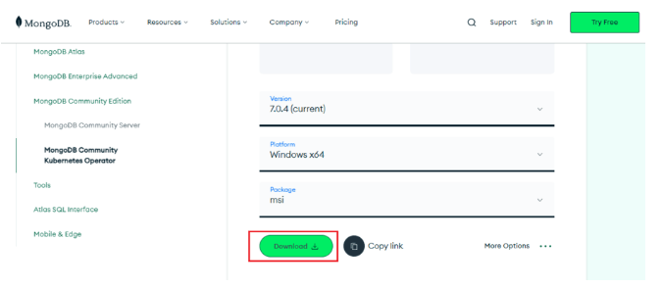
Here, You can select any version, Windows, and package according to your requirement. For Windows, we need to choose:
- Version: 7.0.4
- OS: Windows x64
- Package: msi
Step 2: When the download is complete open the msi file and click the next button in the startup screen:
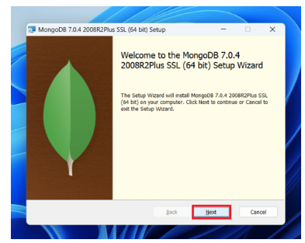
Step 3: Now accept the End-User License Agreement and click the next button:

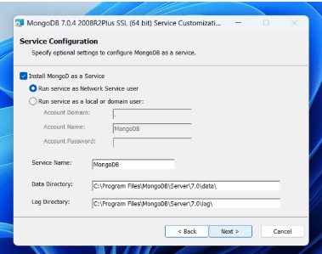
Step 4: Now select the complete option to install all the program features. Here, if you can want to install only selected program features and want to select the location of the installation, then use the Custom option:
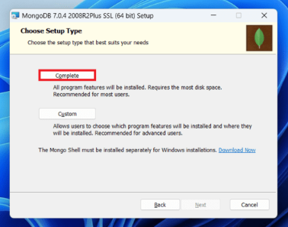
Step 5: Select “Run service as Network Service user” and copy the path of the data directory. Click Next:
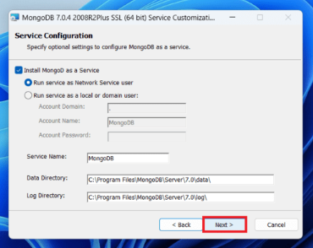

Step 6: Click the Install button to start the MongoDB installation process:

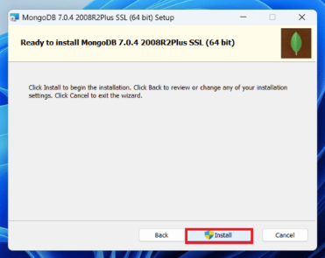

Step 7: After clicking on the install button installation of MongoDB begins:
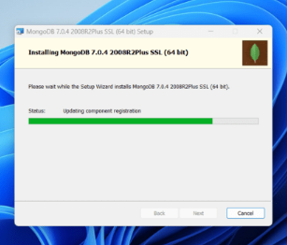
Step 8: Now click the Finish button to complete the MongoDB installation process:
Step 9: Now we go to the location where MongoDB installed in step 5 in your system and copy the bin path:
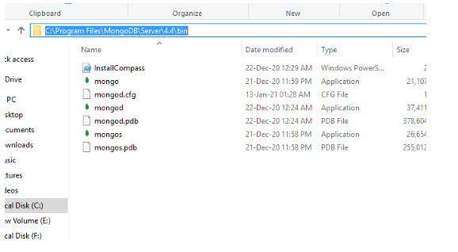
Step 10: Now, to create an environment variable open system properties >> Environment Variable >> System variable >> path >> Edit Environment variable and paste the copied link to your environment system and click Ok:
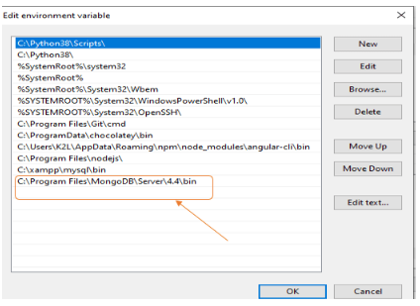
Step 11: After setting the environment variable, we will run the MongoDB server, i.e. mongod. So, open the command prompt and run the following command:

When you run this command you will get an error i.e. C:/data/db/ not found.
Step 12: Now, Open C drive and create a folder named “data” inside this folder create another folder named “db”. After creating these folders. Again open the command prompt and run the following command:

Now, this time the MongoDB server(i.e., mongod) will run successfully.
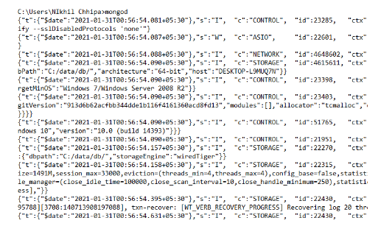
Run mongo Shell
Step 13: Now we are going to connect our server (mongod) with the mongo shell. So, keep that mongod window and open a new command prompt window and write mongo. Now, our mongo shell will successfully connect to the mongod.
Important Point: Please do not close the mongod window if you close this window your server will stop working and it will not able to connect with the mongo shell.

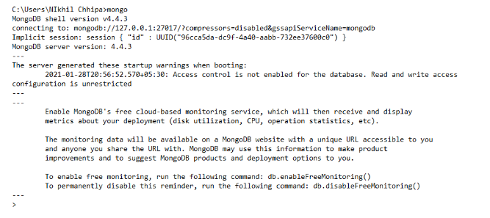
- Start MongoDB Shell
Launch the MongoDB shell to perform basic CRUD operartions.
- Switch a Database (optional)
If you want to use a specific database switch to that database using the ‘use’ command. If the database doesn’t exist, MongoDB will create it implicitly when you insert data into it:
test> use bookDB
switched to db bookDB
bookDB>
- Create the ‘ProgrammingBooks’ Collection:
To create the ProgrammingBooks collection, use the createCollection() method. This step is optional because MongoDB will automatically create the collection when you insert data into it, but you can explicitly create it if needed:
bookDB> db.createCollection("ProgrammingBooks")
This command will create an empty ProgrammingBooks collection in the current database (bookDB).
- Insert Operations:
- Insert 5 Documents into the ProgrammingBooks Collection :

Now, insert 5 documents representing programming books into the ProgrammingBooks collection using the insertMany() method:
bookDB> db.ProgrammingBooks.insertMany([
{
title: "Clean Code: A Handbook of Agile Software Craftsmanship",
author: "Robert C. Martin",
category: "Software Development",
year: 2008
},
{
title: "JavaScript: The Good Parts",
author: "Douglas Crockford",
category: "JavaScript",
year: 2008
},
{
title: "Design Patterns: Elements of Reusable Object-Oriented Software",
author: "Erich Gamma, Richard Helm, Ralph Johnson, John Vlissides",
category: "Software Design",
year: 1994
},
{
title: "Introduction to Algorithms",
author: "Thomas H. Cormen, Charles E. Leiserson, Ronald L. Rivest, Clifford Stein",
category: "Algorithms",
year: 1990
},
{
title: "Python Crash Course: A Hands-On, Project-Based Introduction to Programming",
author: "Eric Matthes",
category: "Python",
year: 2015
}
])

b. Insert a Single Document into ProgrammingBooks:
Use the insertOne() method to insert a new document into the ProgrammingBooks collection:
bookDB> db.ProgrammingBooks.insertOne({
title: "The Pragmatic Programmer: Your Journey to Mastery",
author: "David Thomas, Andrew Hunt",
category: "Software Development",
year: 1999
})

- Read(Query) Operations:
- Find all the Documents.
To retrieve all the documents from the ‘ProgrammingBooks’ collection:
bookDB> db.ProgrammingBooks.find().pretty()
Output:
[
{
_id: ObjectId('……'),
title: 'Clean Code: A Handbook of Agile Software Craftsmanship',
author: 'Robert C. Martin',
category: 'Software Development',
year: 2008
},
{
_id: ObjectId('……'),
title: 'JavaScript: The Good Parts',
author: 'Douglas Crockford',
category: 'JavaScript',
year: 2008
},
{
_id: ObjectId('……'),
title: 'Design Patterns: Elements of Reusable Object-Oriented Software',
author: 'Erich Gamma, Richard Helm, Ralph Johnson, John Vlissides',
category: 'Software Design',
year: 1994
},
{
_id: ObjectId('……'),
title: 'Introduction to Algorithms',
author: 'Thomas H. Cormen, Charles E. Leiserson, Ronald L. Rivest, Clifford Stein',
category: 'Algorithms',
year: 1990
},
{
_id: ObjectId('……'),
title: 'Python Crash Course: A Hands-On, Project-Based Introduction to Programming',
author: 'Eric Matthes',
category: 'Python',
year: 2015
},
{
_id: ObjectId('……'),
title: 'The Pragmatic Programmer: Your Journey to Mastery',
author: 'David Thomas, Andrew Hunt',
category: 'Software Development',
year: 1999
}
]
- Find Documents Matching a Condition:
To find books published after the year 2000:
bookDB> db.ProgrammingBooks.find({ year: { $gt: 2000 } }).pretty()
[
{
_id: ObjectId('……'),
title: 'Clean Code: A Handbook of Agile Software Craftsmanship',
author: 'Robert C. Martin',
category: 'Software Development',
year: 2008
},
{
_id: ObjectId('……'),
title: 'JavaScript: The Good Parts',
author: 'Douglas Crockford',
category: 'JavaScript',
year: 2008
},
{
_id: ObjectId('……'),
title: 'Python Crash Course: A Hands-On, Project-Based Introduction to Programming',
author: 'Eric Matthes',
category: 'Python',
year: 2015
}
]
- Update Operations:
- Update Single Document:
To update a specific book (eg. Change the author of a book)
bookDB>db.ProgrammingBooks.updateOne(
{ title: "Clean Code: A Handbook of Agile Software Craftsmanship" },
{ $set: { author: "Robert C. Martin (Uncle Bob)" } }
)
//verify by displaying books published in year 2008
bookDB> db.ProgrammingBooks.find({ year: { $eq: 2008 } }).pretty()
[
{
_id: ObjectId('…………..'),
title: 'Clean Code: A Handbook of Agile Software Craftsmanship',
author: 'Robert C. Martin (Uncle Bob)',
category: 'Software Development',
year: 2008
},
{
_id: ObjectId('…………..'),
title: 'JavaScript: The Good Parts',
author: 'Douglas Crockford',
category: 'JavaScript',
year: 2008
}
]
- Update Multiple Documents:
To update multiple books (e.g., update the category of books published before 2010):
bookDB> db.ProgrammingBooks.updateMany(
{ year: { $lt: 2010 } },
{ $set: { category: "Classic Programming Books" } }
)
//verify the update operation by displaying books published before year 2010
bookDB> db.ProgrammingBooks.find({ year: { $lt: 2010 } }).pretty()
[
{
_id: ObjectId('…………..'),
title: 'Clean Code: A Handbook of Agile Software Craftsmanship',
author: 'Robert C. Martin (Uncle Bob)',
category: 'Classic Programming Books',
year: 2008
},
{
_id: ObjectId('…………..'),
title: 'JavaScript: The Good Parts',
author: 'Douglas Crockford',
category: 'Classic Programming Books',
year: 2008
},
{
_id: ObjectId('…………..'),
title: 'Design Patterns: Elements of Reusable Object-Oriented Software',
author: 'Erich Gamma, Richard Helm, Ralph Johnson, John Vlissides',
category: 'Classic Programming Books',
year: 1994
},
{
_id: ObjectId('…………..'),
title: 'Introduction to Algorithms',
author: 'Thomas H. Cormen, Charles E. Leiserson, Ronald L. Rivest, Clifford Stein',
category: 'Classic Programming Books',
year: 1990
},
{
_id: ObjectId('…………..'),
title: 'The Pragmatic Programmer: Your Journey to Mastery',
author: 'David Thomas, Andrew Hunt',
category: 'Classic Programming Books',
year: 1999
}
]
- Delete Operations:
- Delete a Single Document:
To delete a specific book from the collection (e.g., delete a book by title):

bookDB> db.ProgrammingBooks.deleteOne({ title: "JavaScript: The Good Parts" })
{ acknowledged: true, deletedCount: 1 }
You can check whether the specified document is deleted by displaying the contents of the collection.
- Delete Multiple Documents:
To delete multiple books based on a condition (e.g., delete all books published before 1995):

bookDB> db.ProgrammingBooks.deleteMany({ year: { $lt: 1995 } })
{ acknowledged: true, deletedCount: 2 }
You can check whether the specified documents were deleted by displaying the contents of the collection.
- Delete all the Documents in a Collection:
To delete all documents in a collection (e.g., ProgrammingBooks), use the deleteMany() method with an empty filter {}:
//delete all documents in a collection

bookDB> db.ProgrammingBooks.deleteMany({})
{ acknowledged: true, deletedCount: 3 }

//verify by displaying the collection

bookDB> db.ProgrammingBooks.find().pretty()
- Delete the Collection using drop():
To delete a collection named ProgrammingBooks, use the drop() method with the name of the collection:

bookDB> show collections
ProgrammingBooks

bookDB> db.ProgrammingBooks.drop()
true

bookDB> show collections

bookDB>

The command db.ProgrammingBooks.drop( ) will permanently delete the ProgrammingBooks collection from the current database (bookDB).

After deleting the collection, you can verify that it no longer exists by listing all collections in the database using the command ‘show collections’.

